EXPERIMENT-2

Design a database for a College Admission System. Create Student and Department tables and apply appropriate integrity constraints to ensure valid and consistent data. Demonstrate all six constraints with suitable SQL statements
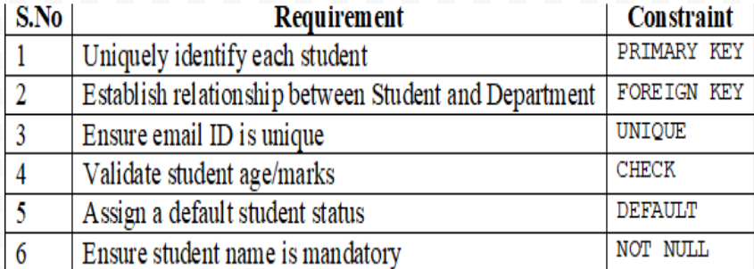

Aim:
To design a database for a College Admission System by creating Student and Department tables and applying six integrity constraints: PRIMARY KEY, FOREIGN KEY, UNIQUE, CHECK, DEFAULT, and NOT NULL.
Step 1: Create the Department Table
CREATE TABLE Department (
Dept_ID INT PRIMARY KEY,
Dept_Name VARCHAR(50) NOT NULL
);
Output – Department table created
Dept_ID | Dept_Name
(empty)
Step 2: Create the Student Table with Six Constraints
CREATE TABLE Student (
Student_ID INT PRIMARY KEY,
FirstName VARCHAR(30) NOT NULL,
LastName VARCHAR(30) NOT NULL,
Email VARCHAR(100) UNIQUE,
Age INT CHECK (Age >= 17 AND Age <= 30),
Marks INT CHECK (Marks >= 0 AND Marks <= 100),
Status VARCHAR(20) DEFAULT 'Pending',
Dept_ID INT,
FOREIGN KEY (Dept_ID)
REFERENCES Department(Dept_ID)
);
Constraints applied:
- PRIMARY KEY – uniquely identifies each student.
- FOREIGN KEY – connects Student with Department.
- UNIQUE – prevents duplicate email addresses.
- CHECK – validates age and marks.
- DEFAULT – assigns Pending when status is omitted.
- NOT NULL – makes first and last names mandatory.
Step 3: Insert Values into Department
INSERT INTO Department VALUES
(1, 'CSE'),
(2, 'ECE'),
(3, 'IT');
Output – Department table
Dept_ID | Dept_Name
1 | CSE
2 | ECE
3 | IT

Step 4: Insert Values into Student
INSERT INTO Student
(Student_ID, FirstName, LastName, Email, Age, Marks, Dept_ID)
VALUES
(101, 'Arun', 'Kumar', 'arun@gmail.com', 20, 85, 1),
(102, 'Priya', 'Devi', 'priya@gmail.com', 19, 90, 2),
(103, 'Kumar', 'Raj', 'kumar@gmail.com', 21, 78, 3);
Since Status is omitted, the default value Pending is assigned automatically.

Step 5: Display the Student Table
SELECT * FROM Student;
Output – Student table
Student_ID | FirstName | LastName | Email | Age | Marks | Status | Dept_ID
101 | Arun | Kumar | arun@gmail.com | 20 | 85 | Pending | 1
102 | Priya | Devi | priya@gmail.com | 19 | 90 | Pending | 2
103 | Kumar | Raj | kumar@gmail.com | 21 | 78 | Pending | 3

Step 6: Demonstrate the Six Constraints
Run each test separately after completing the previous steps. The invalid examples are expected to produce constraint errors.
1. PRIMARY KEY
INSERT INTO Student
VALUES (101, 'Ravi', 'Sharma', 'ravi@gmail.com',
20, 80, 'Pending', 1);
2. FOREIGN KEY
INSERT INTO Student
VALUES (104, 'Ravi', 'Sharma', 'ravi@gmail.com',
20, 80, 'Pending', 99);
3. UNIQUE
INSERT INTO Student
VALUES (104, 'Ravi', 'Sharma', 'arun@gmail.com',
20, 80, 'Pending', 1);

4. CHECK
INSERT INTO Student
VALUES (104, 'Ravi', 'Sharma', 'ravi@gmail.com',
15, 80, 'Pending', 1);
5. DEFAULT
INSERT INTO Student
(Student_ID, FirstName, LastName, Email, Age, Marks, Dept_ID)
VALUES (104, 'Ravi', 'Sharma', 'ravi@gmail.com', 22, 88, 1);

SELECT * FROM Student;
6. NOT NULL
INSERT INTO Student
VALUES (105, NULL, 'Sharma', 'test@gmail.com',
20, 80, 'Pending', 1);

Result
The Student and Department tables were created successfully. All six integrity constraints were applied to maintain data accuracy, validity, and consistency in the College Admission System.

